
SCENARIO BASED ASSIGNMENT

Course Code: ITA02
Course Name: WEB TECHNOLOGY
Design and Development of an Interactive University Course Registration Portal
Student Name: S.AMIRTHAVALLI, G.KEERTHANA
Register Number: 192521365, 192521446
Department: B.Tech.IT, B.Tech IT

1. Introduction
Every semester, students have to go through a course registration process, and in many colleges this is still handled through paper forms or scattered spreadsheet files. This creates confusion because students do not always know which courses are open, how many credits a course carries, or whether they have filled every required detail correctly before submitting the form. A web-based registration portal solves this problem by putting all the required information on one page and by checking the entries right in the browser before anything is accepted.
This assignment asked us to design a University Course Registration Portal using the concepts covered in Unit I and Unit II of Web Technology, mainly HTML/XHTML for structure, CSS for layout and styling, and JavaScript for validation and dynamic behaviour. The portal built for this assignment is called the Greenfield University Course Registration Portal. It shows the university name, a navigation bar, a table of available courses, registration instructions, a registration form, and contact details, all inside a single responsive web page.
The main idea behind the project is that a student should be able to open the page, read about the courses being offered, check whether they are eligible, fill in their details, choose the courses they want, and immediately see a summary of what they registered for, without the page reloading even once. This is achieved by combining HTML for the page structure, CSS for a clean and professional appearance across different screen sizes, and JavaScript for validating the form and generating the summary dynamically using the Document Object Model.
While developing the page, I tried to keep the design realistic, similar to what an actual university portal might look like, rather than a very plain or a very fancy page. The focus stayed on making sure the functional requirements from the assignment were met correctly, and the styling was kept clean enough to look presentable on both a laptop screen and a mobile screen.

2. Objectives
The objectives that this project was built around are listed below:
- To design a properly structured university web page containing a header, navigation bar, and separate content sections.
- To display the list of courses being offered using an HTML table with course code, course name, credits and course type.
- To provide clear registration instructions and eligibility conditions using ordered and unordered lists.
- To build a registration form that collects the student's register number, name, email, department, semester and selected courses.
- To validate the form on the client side using JavaScript so that incomplete or incorrect entries are caught before processing.
- To allow students to select more than one course and store this selection using JavaScript arrays and objects.
- To write a reusable function that calculates the total number of selected courses and the total credit value.
- To show the final registration summary on the same page without any reload, using DOM manipulation.
- To make sure the page layout adjusts properly on smaller screens using Flexbox, Grid and media queries.

3. Technologies and Concepts Used
The portal uses only client-side technologies, since this assignment is based on Unit I and Unit II which cover HTML, CSS and JavaScript fundamentals.

HTML / XHTML
HTML was used to build the skeleton of the page - the header, navigation bar, sections for home, courses, registration and contact, the course table, the lists for instructions, and the registration form itself. Elements were properly nested and closed to keep the structure valid, and semantic tags such as header, nav, main, section, footer and address were used instead of relying only on generic div tags.

CSS - Selectors, Box Model, Flexbox/Grid, Responsive Design
CSS handles all the visual styling. Type selectors, class selectors and id selectors were used to target different elements. The box model properties (padding, margin, border, border-radius) were applied to give the sections a card-like appearance. CSS Grid was used for the registration form and for the two-column instruction layout, while Flexbox was used for the navigation bar. Media queries switch these multi-column layouts into a single column once the screen width goes below 720 pixels, which keeps the form usable on a phone.

JavaScript - Arrays, Objects, Functions, Validation, DOM
JavaScript is used for everything that needs to happen without reloading the page. The five courses are stored as an array of objects, each object holding the code, name, credit value and type of one course. A validation function checks every mandatory field, and a separate reusable function calculates the total course count and total credits whenever the form is submitted. The final part uses the Document Object Model to update the summary section directly, and console.log() statements were placed at key points so the values could be checked in the browser console while testing.

4. System Design / Portal Structure
The page is organised into six main parts, one after another, and the navigation bar links to each part using internal hyperlinks (the # symbol followed by the section id, such as #courses or #registration). Clicking a navigation link scrolls the page down to that section instead of opening a new page.
- Header - shows the university name and a short line describing the portal.
- Navigation - a horizontal bar with links to Home, Courses, Registration and Contact.
- Home section - a short welcome message with quick links, including one external link.
- Courses section - the table listing the five available courses.
- Registration instructions section - lists showing how to register and the eligibility conditions.
- Registration section - the form itself, followed by the summary box that appears after submission.
- Contact section - the department address, phone number and email, placed inside an address tag.
Keeping everything on one page with anchor links made sense for this assignment since the whole portal is meant to be simple and does not need multiple HTML files or server-side routing.

5. Course Information
The course list is shown using an HTML table, since a table is the most natural way to present rows of structured data where every course has the same set of attributes (code, name, credits, type). A table also lines up the values in columns, which makes it easy for a student to compare credit values across courses at a glance, something that a plain list would not do as clearly.
Course Code | Course Name | Credits | Course Type
IT101 | Web Technology | 4 | Core
IT102 | Database Management Systems | 4 | Core
IT103 | Data Structures | 3 | Core
IT104 | Computer Networks | 3 | Core
IT105 | Software Engineering | 3 | Elective
These five courses (IT101 to IT105) are sample courses created only for this assignment and are not official Greenfield University or actual college courses. They were chosen so that both core and elective course types appear in the table, and so the credit values are not identical across all courses, which is useful later when testing the credit calculation.

6. Registration Instructions and Eligibility
Below the course table, the page lists basic instructions for filling the form correctly, along with the minimum eligibility conditions a student should meet before registering.
- Enter a valid register number in the correct format.
- Enter the full student name, not initials.
- Use a working and correctly formatted email address.
- Select the correct department from the drop-down list.
- Select the current semester, which should be a number from 1 to 8.
- Choose one or more courses from the available list.
- Check the registration summary shown after submitting before considering the registration final.
These are kept simple on purpose, since the assignment does not require complicated university-level rules, only enough conditions to demonstrate form validation properly.

7. Registration Form
The registration form collects the following fields:
- Register Number - a text field, required so the student can be identified uniquely.
- Student Name - a text field, required to know who is registering.
- Email - a text field validated using a JavaScript pattern check, required so the student can be contacted about their registration.
- Department - a drop-down list, required so the registration is linked to the correct department.
- Semester - a number field restricted between 1 and 8, required to know which semester the student is currently in.
- Course Selection - a multi-select list built from the same course array used in the table, required so at least one course is chosen.
Each field was made mandatory because none of them are optional in a real registration process - missing even one of these would make the registration incomplete.

8. CSS Design and Responsive Interface
For the visual design, a dark blue and amber colour combination was used to give the portal a university-like appearance, with the header and navigation bar in dark blue and hover effects shown in amber/orange. Each section is wrapped in a card with padding, a light border and a subtle shadow, which separates the content visually without needing heavy borders everywhere.
The box model was applied throughout - padding inside form fields and buttons, margin between sections, and border-radius to soften the corners of cards, inputs and buttons. The navigation bar uses Flexbox so the links stay centred and wrap properly on narrow screens, while the registration form and the instructions section use CSS Grid to arrange fields side by side on a larger screen. Hover effects were added on the navigation links, the table rows and the buttons, so the interface feels responsive to user interaction even before anything is clicked.
A single media query at 720 pixels changes the grid-based sections (home layout, instructions layout, and the form) from two columns into one column, and also reduces the navigation link padding slightly. This way, on a mobile screen the form fields stack vertically one below another instead of squeezing into two narrow columns, which keeps the page usable without horizontal scrolling.

9. JavaScript Validation
Validation happens when the form's submit event is triggered, and event.preventDefault() is called immediately so the page does not reload, which allows all the checking and the summary display to happen on the same page.
The validateForm() function checks each field one by one - register number and student name are checked to make sure they are not left blank, email is checked using a regular expression pattern to confirm it contains an '@' symbol and a domain part, department is checked to confirm an option was actually chosen, semester is checked to confirm it is a number between 1 and 8, and course selection is checked to confirm at least one option is selected in the multi-select list. If any of these checks fail, an error message appears right below that specific field, and a general message appears near the submit button telling the student to correct the highlighted fields.
If even one field fails validation, the function stops there and the registration summary is not generated. This assignment only covers client-side JavaScript, so no server-side or database-level validation is part of this portal - all the checks happen inside the browser using plain JavaScript.

10. JavaScript Array / Object for Courses
Course details are stored as an array of five objects, and each object represents one course with four properties - code, name, credits and type. This mirrors the same data shown in the course table, so the table and the JavaScript logic stay consistent with each other. A short version of the structure looks like this in the explanation:
courseData = [ { code: "IT101", name: "Web Technology", credits: 4, type: "Core" }, ... ]
When the form is submitted, the multi-select course field is read using selectedOptions, and the selected course codes are collected into a plain array. This array of codes is then compared against the courseData array using the filter() method, which returns only the course objects that match what the student picked. These matched objects are what get displayed in the summary list and used for the credit calculation.

11. Function for Credit Calculation
A function called calculateCourseSummary() was written to be reusable, meaning it can be called again whenever needed instead of writing the same logic separately. It takes the array of selected course codes as input, filters the full course list to find the matching course objects, counts how many were selected, and adds up their credit values using the reduce() method.
For example, if a student selects three courses carrying 4, 3 and 3 credits, the function returns a total course count of 3 and a total credit value of 10. The function returns all three pieces of information together - the matched course objects, the total course count, and the total credit value - so the calling code can use whichever part it needs for the summary.

12. Dynamic Registration Summary
Once validation passes, the page calls calculateCourseSummary() and then passes the result to a displaySummary() function. This function uses DOM methods such as getElementById() and textContent to fill in the student's name, register number and department inside the summary box, and creates a new list item for every selected course using createElement() and appendChild().
The summary box itself is a div that stays hidden using CSS until a class is added to it through JavaScript, at which point it becomes visible below the form. Because all of this happens through DOM manipulation inside the submit event handler, the browser never sends the form data anywhere and never reloads the page - the whole summary appears instantly on the same screen.
The summary displays the Student Name, Register Number, Department, the list of Selected Courses, and two small stat cards showing the Total Courses and Total Credits, which satisfies the summary requirement from the assignment.

13. Debugging and Developer Tools
While testing the multiple course selection, I noticed that the total credit value shown in the summary was not matching what it should have been when more than one course was selected together. I opened the browser Developer Tools, went to the Console tab, and added console.log() statements right after reading the selected options and again after calling the calculation function, to check what values were actually being passed around.
The console output showed that the selected course codes array was being read correctly, but the filter condition inside calculateCourseSummary() was comparing values in a way that missed some matches, which meant some selected courses were not being included in the total. After adjusting the comparison logic inside the filter() call and testing again with the same three-course selection, the console log showed the correct matched courses, and the total course count and total credit value updated correctly in the summary box. This was a useful reminder of how helpful console.log() and the browser console are when a calculation looks wrong but the form itself appears to be working fine.

14. Testing
The table below lists the test cases used to check the form validation, course selection and responsive layout.
Test Case | Input / Action | Expected Result | Actual Result | Status
Empty student name | Submit form leaving Student Name blank | Error message under the field, summary not shown | Error message displayed as expected | Pass
Invalid email | Enter 'aditi.university' without @ symbol | Email error message shown | Error shown, form blocked from submitting | Pass
Invalid semester | Enter semester value as 9 | Error asking for value between 1 and 8 | Error message displayed correctly | Pass
No course selected | Submit form without selecting any course | Error asking to select at least one course | Error message shown, summary hidden | Pass
Valid registration | Fill all fields correctly, select 2 courses | Summary appears with correct totals | Summary displayed with correct name, credits | Pass
Multiple course selection | Select IT101, IT102 and IT104 together | Total courses = 3, total credits = 11 | Values matched after correction (see Section 14) | Pass
Mobile / small screen | Resize browser window to about 375px width | Form fields and table stack in single column | Layout adjusted correctly using media query | Pass

15. Result / Expected Output
The completed portal provides a single page with organised navigation linking to the home, courses, registration and contact sections. It shows a course table with five sample courses, a registration form with all six required fields, and JavaScript-based validation that blocks incomplete or incorrect submissions. Once the form passes validation, the selected courses are displayed along with the total number of courses and total credit value, and the full registration summary appears on the same page without a reload. The layout also adjusts correctly when viewed on a smaller screen, switching from a multi-column layout to a single column.

16. Learning Outcome
This assignment gave a practical understanding of how HTML, CSS and JavaScript work together on a single page rather than as separate topics. Structuring the page with proper HTML elements made it clear why semantic tags matter for organising content logically. Working with CSS Grid, Flexbox and media queries showed how the same layout can be made to work on both a desktop and a mobile screen without writing separate pages.
On the JavaScript side, this project helped in understanding how arrays of objects can represent structured data like a course list, how a function can be written once and reused for a calculation instead of repeating the same logic, and how form validation actually works step by step before any data is processed further. Using the Developer Tools console to trace the credit calculation issue also showed how useful console.log() is for checking what a variable actually contains at a certain point in the code, instead of just guessing why something is not working.

17. Conclusion
The Greenfield University Course Registration Portal built for this assignment meets all the requirements given in the scenario - a properly structured HTML page with navigation, a course table, instruction lists, hyperlinks, a registration form, responsive CSS styling, and JavaScript-based validation and calculation. The registration summary is generated and displayed dynamically without reloading the page, using arrays, objects, functions and DOM manipulation.
Overall, this project shows how a fairly simple set of web technologies covered in Unit I and Unit II can be combined to build something that behaves close to a real registration system, at least on the client side. The debugging step also showed that even a small logic mistake in a filter condition can affect the final output, and that checking the console early can save a lot of time while testing.

18. Code / Screenshot References
The following screenshots would be inserted here after running the portal in a browser:

OUTPUT1: HOME PAGE


OUTPUT2: COURSE TABLE

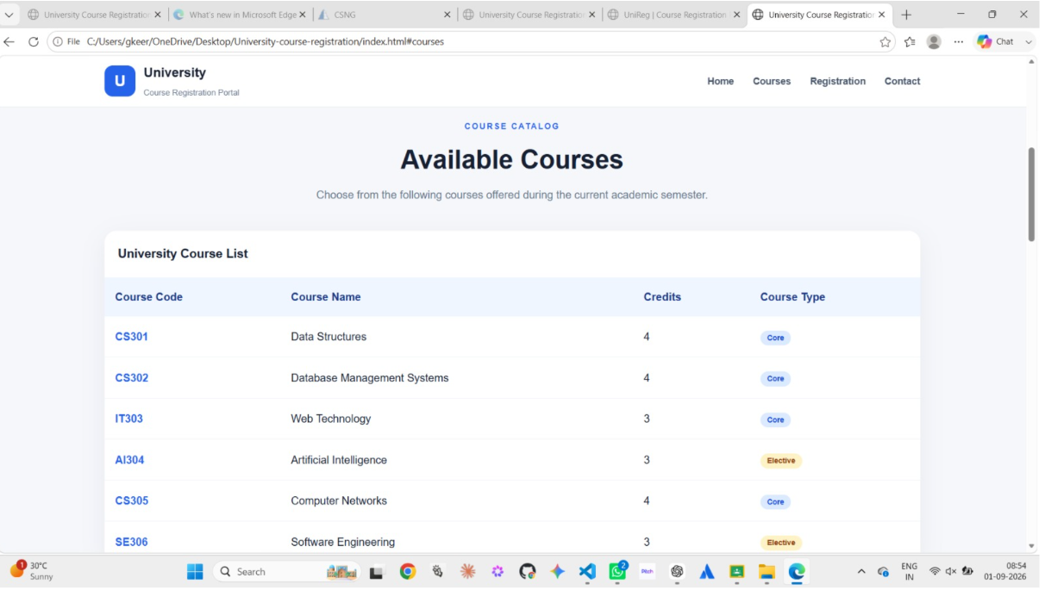

OUTPUT 3:REGISTRATION FORM

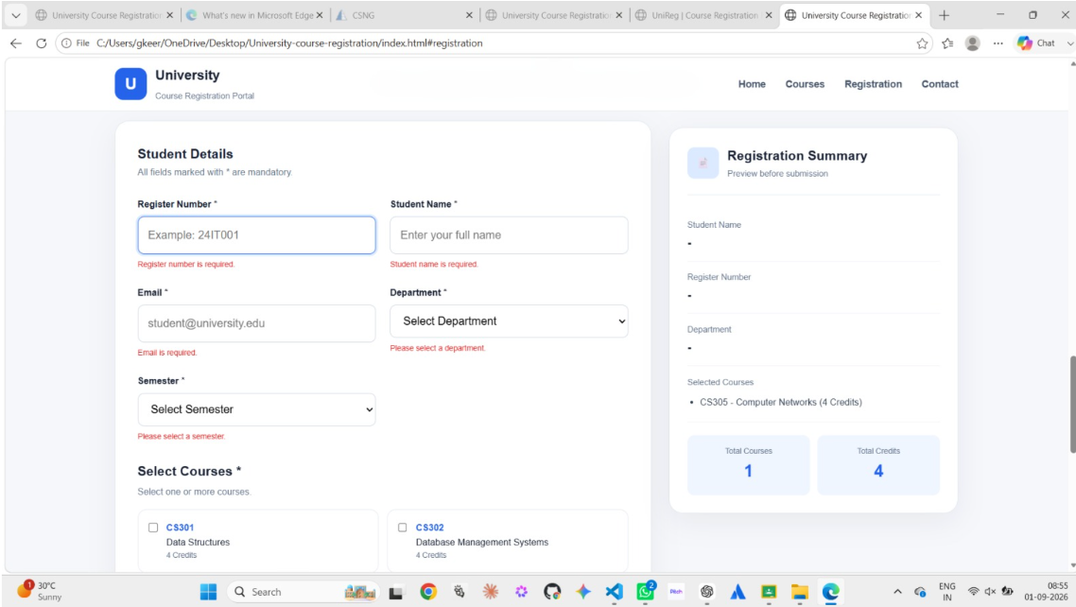

OUTPUT 4: VALIDATION MESSAGE

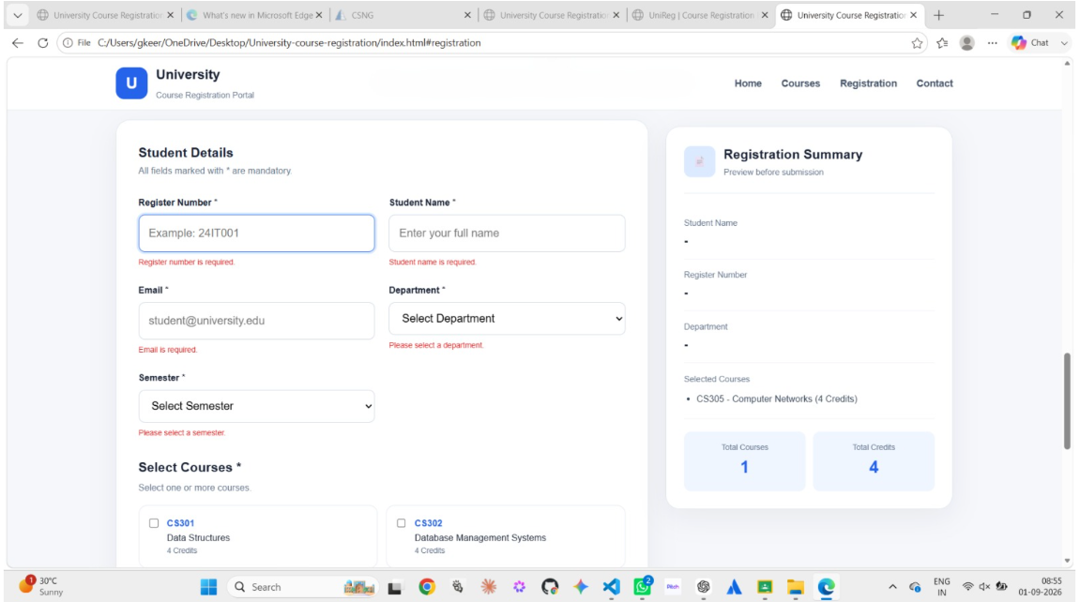

OUTPUT 5:REGISTRATION SUMMARY

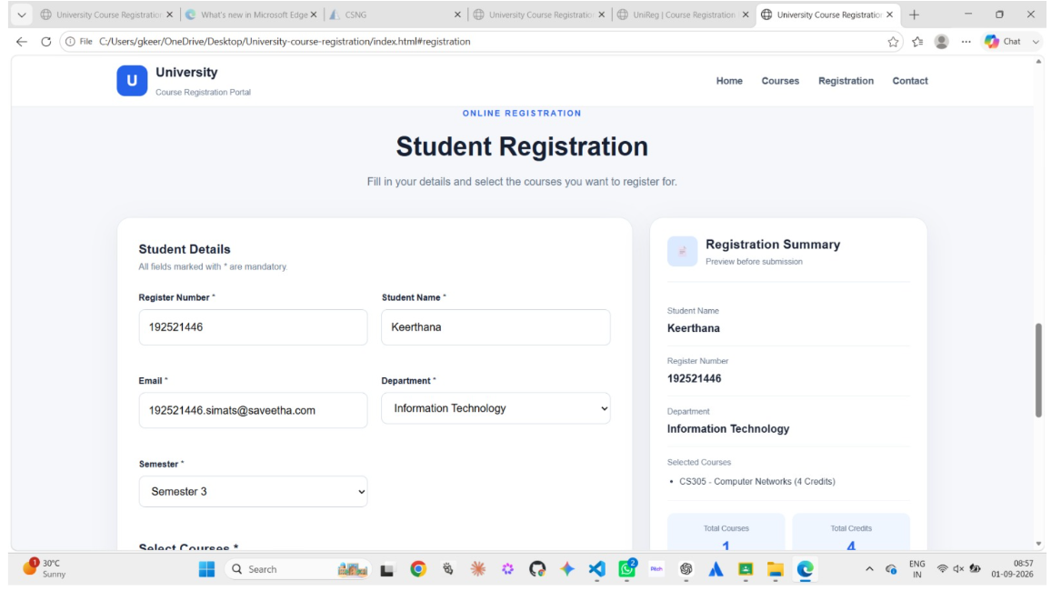

OUTPUT 6 :DEVELOPER CONSOLE/DEBUGGING

